Experiment 9: Design DFA Using Simulator to Accept the Input Strings "a", "ac", and "bac"
Aim
To design and simulate a Deterministic Finite Automaton (DFA) that accepts only the input strings "a", "ac", and "bac".

Algorithm
- Start from the initial state q0.
- Read the input string one symbol at a time.
- Follow the transition corresponding to the current input symbol.
- If an invalid transition occurs, move to the dead state.
- After reading the entire string, check the current state.
- If the current state is one of the accepting states (q1, q2, or q5), then accept the string.
- Otherwise, reject the string.

Procedure
- Open the DFA Simulator (such as JFLAP).
- Create the required states: q0, q1, q2, q3, q4, q5, and qd (dead state).
- Mark q0 as the initial state.
- Mark q1, q2, and q5 as the final (accepting) states.
- Add transitions according to the DFA transition table.
- Save the DFA.
- Run the simulator with the input strings:
  - a
  - ac
  - bac
- Observe whether each string is accepted or rejected.

Input
a
ac
bac

Output
Input: a → Accepted
Input: ac → Accepted
Input: bac → Accepted
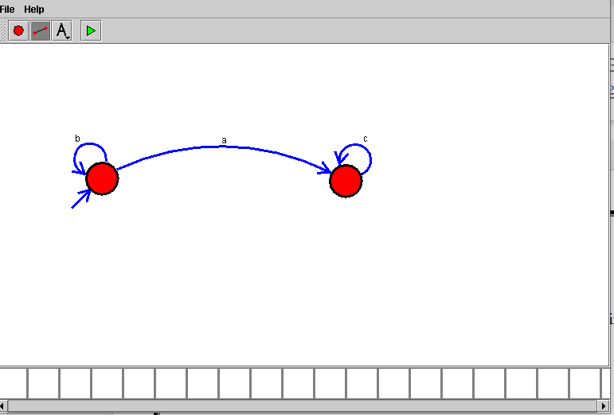

Result
Thus, the Deterministic Finite Automaton (DFA) was successfully designed and simulated to accept the input strings "a", "ac", and "bac". The simulator produced the expected results, and all specified strings were accepted successfully.

